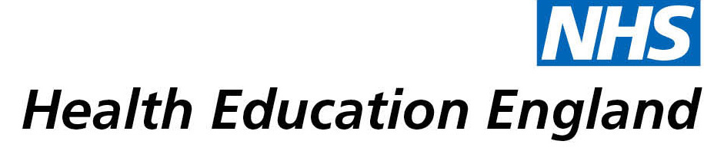

# Library and Knowledge Services case study

# Community Nasoendoscopy - Lancashire Teaching Hospitals NHS Foundation Trust

16th June 2021

## Reason for enquiry

Our requester contacted the library service because she wanted to investigate the possibility of setting up a community nasoendoscopy service in the region. She asked us to undertake a literature search and was particularly interested to know if community nasoendoscopy was being practiced elsewhere in the UK or internationally. As a Speech and Language Therapist she was also interested to know if this procedure was being undertaken in the community by other Speech and Language Therapy professionals.

At present, nasoendoscopy procedures are usually undertaken by a doctor in a hospital outpatient setting. However, nurses and allied health professionals such as Speech & Language Therapists can do the procedure in this setting as part of their advanced practice. Nasoendoscopy can be a risky procedure, so specialist training is required and a doctor needs to be available in case of emergencies.

Nasoendoscopy is sometimes undertaken in the community by respiratory and ENT consultants, but is usually done in community hospitals as opposed to patient’s homes. Our requestor wanted to know if there was any evidence around using nasoendoscopy in patient’s own homes and in nursing homes.

## What the knowledge and library specialist did

The library service carried out a comprehensive literature search on the topic. We were able to locate 2 relevant position papers, plus other national resources looking more broadly at moving care from hospital into the community. There was very little evidence available on the use of nasoendoscopy in a community setting.

The evidence shows that although there is research available on the importance and positive impact of moving healthcare closer to home, there is no real evidence on the use of community nasoendoscopy by doctors, nurses or allied health professionals. There are also no examples of such services existing elsewhere in the UK or internationally.

# Impact of input from the library and knowledge service

The search results show that there is no evidence that community nasoendoscopy in patients’ homes or in nursing homes is currently feasible. In addition, there is no evidence to show that Speech & Language Therapists can undertake this procedure safely in a community setting. There is no evidence to recommend a change in practice but the search does highlight areas for future research.

## Immediate Impact

The search results show that there is not enough evidence available to support the use of community nasoendoscopy by Speech & Language Therapists at this time. There will therefore be no immediate change in practice.

## Probable future Impact

It is difficult to ascertain what the future impact of the search will be because due to concerns over patient safety, this change idea is not feasible at the present time. However, the results have shown the need for further investigations if this idea is to be taken forward. After reading the results, our requestor recognised that the following steps would need to be taken:

* An audit of patient need would have to be done to assess why patients cannot come for an outpatient appointment with a doctor for this procedure
* Further research would need to take place to try and find out what the risks would be of Speech & Language Therapists doing nasoendoscopy in the community and if any adverse events have happened previously in a hospital setting
* Safety data from hospital nasoendoscopies would need to be considered

There is no clear future impact but the search has highlighted possible areas for future research.

## Submission by:

Lee Hughes

Tracheostomy Specialist Speech & Language Therapist

## For further information on how you can get similar support contact your local NHS library and knowledge service.